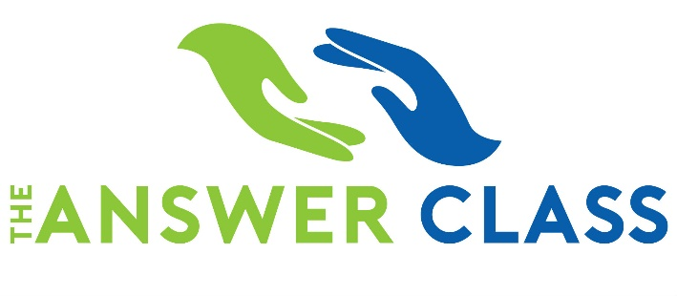
AN EVENING FOR PARENTS ABOUT THE SAT & ACT

Tues., November 12 @ 6:30 pm  MHHS, Media Center
Presented in Partnership with MHHS PTSA
Please join us for a special evening to learn more about the SAT & ACT and how these important tests impact your child’s college application.
This complimentary session includes:
- Differences between SAT & ACT
- Tips and strategies on timing, guessing, and scoring
- Confidence building techniques
- Question and Answer period

WIN A FREE SAT or ACT Prep Class from The Answer Class just by attending this event.

($159 value)

One lucky winner will be selected at the conclusion of the evening’s program. Must be present to win.

Upcoming Mt. Hebron SAT Prep Classes: Room 103
Sat., September 28 from 9:00am-5:30pm
Tu/Thurs Nov. 5 & 7 from 5:30pm-9:30pm
Tu/Thurs Jan. 14 & 16 from 5:30pm-9:30pm
Sat., Feb. 15 & Sat., Feb. 22 from 9:00am-1:00pm
Tu/Thurs April 21 & 23 from 5:30pm-9:30pm
Upcoming Mt. Hebron ACT Prep Class: Room 103
Tu/Thurs Dec. 3 & 5 from 5:30pm-9:30pm
Register today at: http://www.theanswerclass.com/

